Forest Methodist Church

May Newsletter

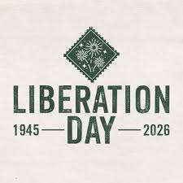

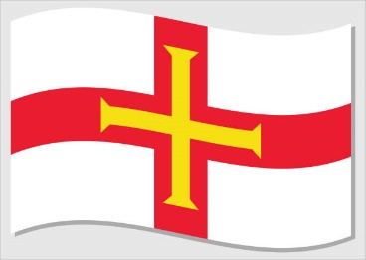
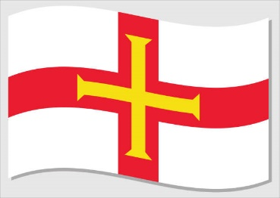

Serve Learn Share Praise
Methodist Church 
Bailiwick of Guernsey
Minister:
Rev’d Jacky Cottrell
The Manse, 2, Le Chene D’Mont, Le Chene,
Forest, GY8 0AL Tel: 234105
Email: revdcottrell@gmail.com

Dear Friends,
May, our month of bank holidays has now begun. So, I hope you have fun and happy times with family and friends. As a circuit we had a good time at the end of April with the visit of Revd Richard Andrew and Matt Forsyth, President and Vice President of the Methodist Conference 2025/26.
I would like to thank Forest Methodist for their gift of hospitality for the workshops. Also, our own Pam, who covered a lot of miles and gave her whole weekend. It really was a privilege of journeying the island with them which they found thoroughly interesting and most breathtaking in its beauty. I hope you enjoyed meeting them too.
What a journey they have had this year from Shetland to us, and most districts in between. Although the majority of their time was here on Guernsey, Richard did go off to Alderney and representatives, including myself, accompanied Matt to Sark.
It was for their 100 years of building in current position, anniversary celebration. They had been too loud in their singing, so the neighbour gave them a piece of land away from him; they took down the church, brick by brick and rebuilt it.
To get Matt there, we picked him up in a car, parked and caught a boat. Climbed off and jumped on a tractor driven trailer, the toast rack. To be met at the top for a ride on a carriage pulled by a horse. A most memorable journey to a church service, he had ever experienced. But he was not done for modes of transport because after the service and a wonderful lunch; Rev David had another ready for him. He hopped on and got the island tour, by bicycle wheels. There are some pictures over the page.
Of course, he did walk too, ‘1 more step along the road I go…… keep me travelling along with you.’ All this travelling along for Matt, he had Jesus travelling with him. Just like our life journey there is much variation for us, but the one constant is our companionship
of Jesus. Although sometimes we do have to push ourselves to keep moving forward and in this our faith is deepened. I
n the bible, Paul talks about it, likening it to a race in 1 Cor: 24- ‘You know that in a race all the runners run, but only one gets the prize. So run to win! All those who compete in the games use self-control so they can win a crown. That crown is an earthly thing that lasts only a short time, but our crown will never be destroyed.’
So keep moving on, however you journey, whatever your pace!
Finally, please put a ‘save the date’ for 4th July, lunch and afternoon in your diaries.
As a circuit we are planning a time together to discuss and vision the future direction of the Guernsey circuit, under the banner ‘Better together’.
Enjoy the bank holidays. Big blessings, Jacky

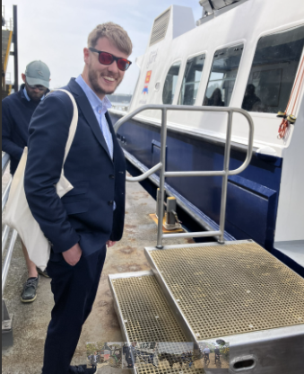
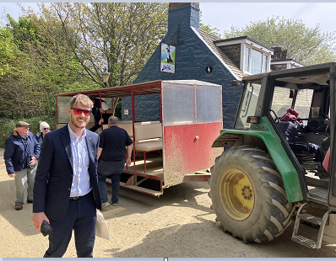
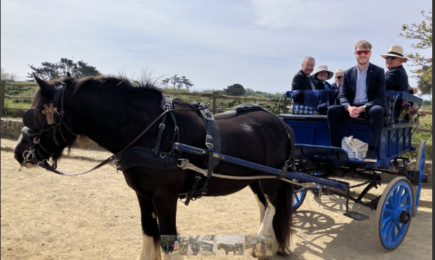
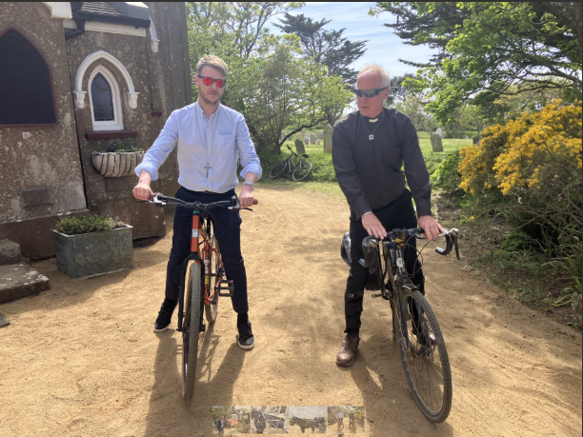
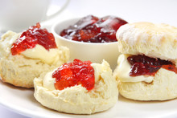

LIBERATION CELEBRATIONS
Come and join us for
CREAM TEAS
Monday 4th May from 2.00pm
To celebrate Liberation
Plants and cakes will also be on sale
Proceeds supporting Shelter Box and
Only One World

Coffee Morning
Bank Holiday Monday, May 4th,
St. Paul's Methodist Church
are holding a Coffee morning with proceeds going to Action for Children.
There will be a cake stall, plant stall, gift stall and books. Refreshments will be served.
The sale is from 10.00 until 11.30 a.m.

MEET & EAT
Meet & Eat will be held here at Church,
Monday 18th May at 7pm
and will be led by Helen Mahoney.
For catering purposes, please add your name to the sheet in the Welcome Area.
Also, please note, the minimum contribution is now £6. This is the first increase ever.
.

FOREST LADIES GROUP.
Ladies come and join us on
Thursday 7th May at 2.00pm
For our own Liberation Memories
Thursday 21st May at 10.00am
Breakfast at the Pearl
Warm welcome to all Ladies
Further details from Beth
Tel: 07781 163564

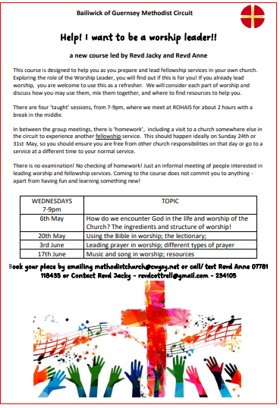

Preaching & Duty Stewart Schedule
God & Marmalade is at 8.45am/The Evening Service is at 6pm

Date | AM Preacher | Duty Steward | PM Preacher | Duty  Stewart
3rd May | Jacky Cottrell | Beth | Jacky Cottrell | Pam
10th May | Howard Stringer | Sarah | Jacky Cottrell (HC) | Beth
17th May | Jacky Cottrell (HC) | Carole | Roger Browning | Sarah
24th May | Keith Le Parmentier | Rosemary | Fellowship | Pam
31st May | Victor Lane | Nev | Fellowship | Beth

Flower Rota
Date
3rd May | Michele de la Huliniere
10th May | Judy Wade
17th May | Wendy Paint
24th May | Cindy Le Messurier
31st May | Angela Galetzine

Welcome Steward Rota
DATE | AM | PM
3rd May | Andrea | Brian
10th May | Sandra | Beth
17th May | Andrea | Brian
24th May | Michèle | Sarah P
31st May | Sandra | Brian

G & M Breakfast Rota
Date | Breakfast | Setting Up | Cloth Wash
3rd May | Debbie D/Rosemary | Carole/Nev | Margaret
10th May | Sandra/Ian  Jenny | Steve/Jan | Beth
17th May | Sarah | Michelle G | Jenny
24th May | Carole/Nev | David | Sarah
31st May | Beth | Leon | Margaret

With grateful thanks to all who give their time to the service of the church

Notices/articles for next month please let Michelle know by
Wednesday 27th May
Tel no: 01481 266019/07781 166019 email: mgilson_gsy@hotmail.com

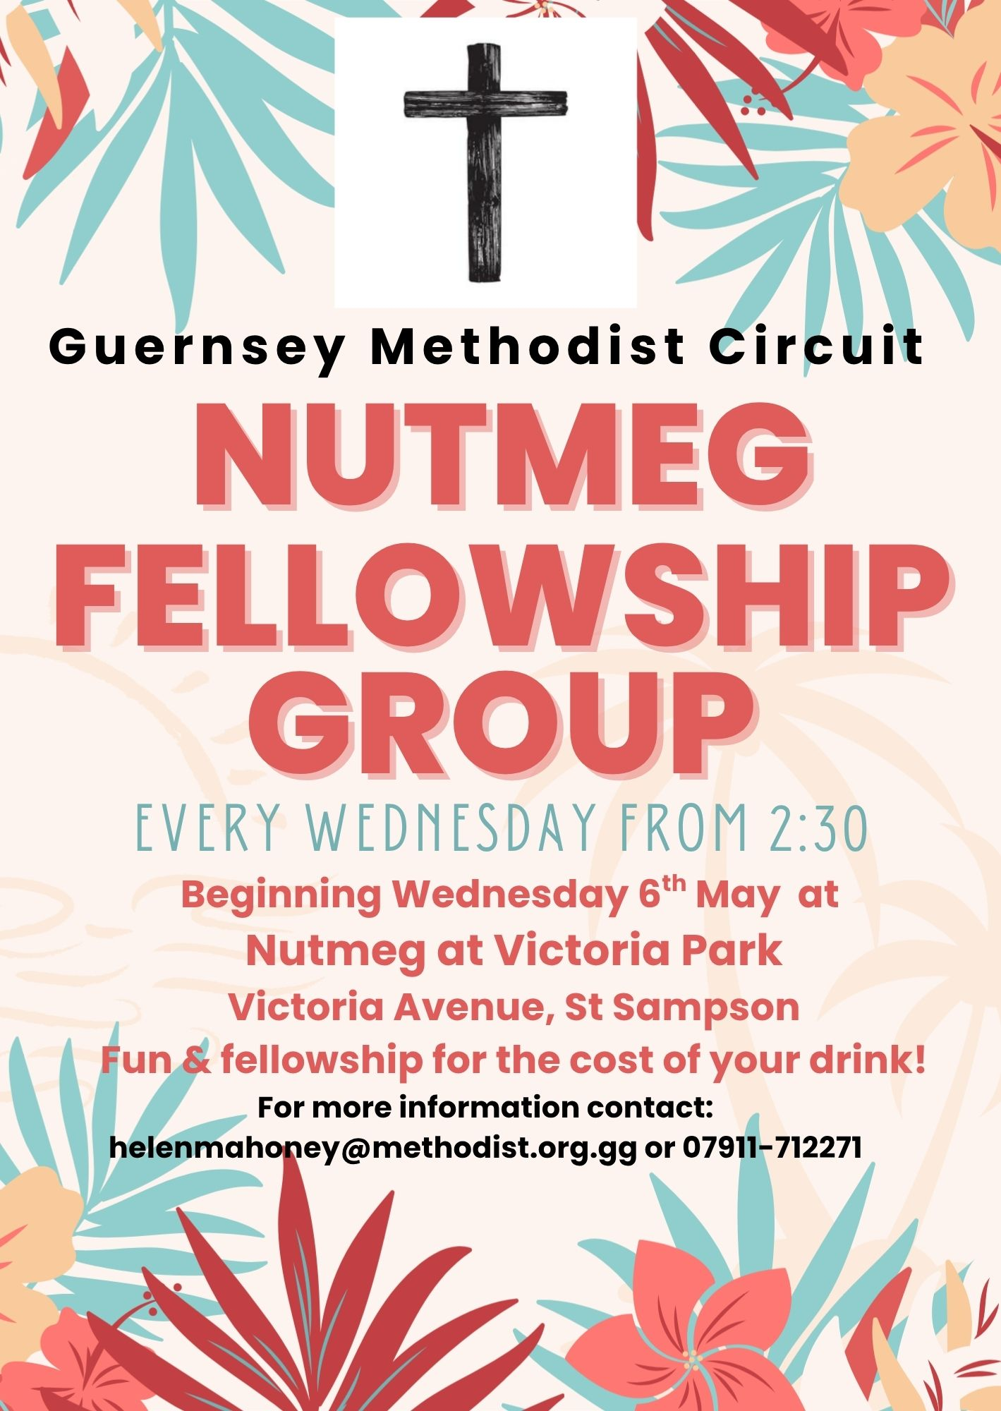

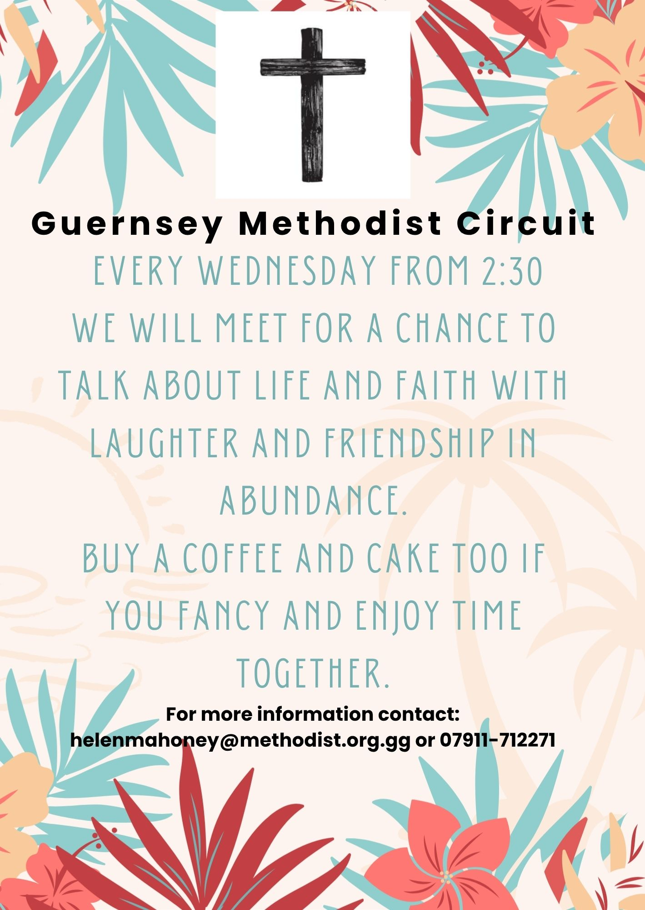

GUERNSEY'S FIRST LIBERATION DAY

As dawn broke on Wednesday 9 May 1945, peace returned to Guernsey.
Off the coast of Guernsey lay two British destroyers, HMS Bulldog and HMS Beagle; they brought to an end five long years of German occupation of the Channel Islands. Soon after their arrival, on that memorable morning, a German armed trawler put out from St Peter Port. Aboard her were Major General O Heine, military adviser to Vice-Admiral F Hoffmeier, the German Commander-in-Chief, together with Kapt Lieutenant A Zimmermann who, rather earlier, had paid a preliminary visit to the Bulldog, aboard which was Brigadier A E Snow, in command of ‘Operation Nest Egg’, code name for the Liberation of these Islands. It was on board that ship that the German surrender of Guernsey took place.
Soon afterwards, an advance party of twenty-two British artillerymen, under the command of Lieutenant Colonel E D Stoneman, came ashore on two small Guernsey craft, each of which wore the White Ensign. In charge of one was a Guernsey man, Lieutenant R E Ferbrache RNVR, and one of the soldiers in the party was Sergeant H J Hamon, another islander. The British troops received a tremendous welcome as they landed at the White Rock, where they were officially greeted by Advocate J E L Martel (HM Procureur) and Police Inspector A Lamy.
Unofficially, they were hailed with exultation by a multitude of cheering islanders, some weeping for joy. Later in the day 200 more troops arrived and marched off the White Rock led by the band of the Duke of Cornwall's Light Infantry which, before the war, had once formed our garrison. Many islanders came in from the country parishes in horse-drawn carts, on bicycles and on foot. Our liberators were overwhelmed at their reception. They gave away chocolate, sweets and cigarettes, receiving in return souvenir German money.
The Bailiff sent this message to King George VI: ‘After nearly five years of German Occupation, the people of your Bailiwick of Guernsey respectfully beg Your Majesty to accept their humble duty and unshaken loyalty.’ The King, in his reply, stated that our message had given him great pleasure and satisfaction. The Prime Minister, Winston Churchill, sent this telegram to the Bailiff: ‘You should have heard the House of Commons cheer at the news of your Liberation.’ The Bailiff replied: ‘We are all deeply touched by, and grateful for your telegram conveying the enthusiasm of the House of Commons at our deliverance.’

PARKING FOR THE AIRPORT at Forest Methodist
We are letting out five spaces, on a first come, first served basis, at a cost of £25 per week or part thereof. These parking spaces will be at the back of the top rear car park and will be delineated.
THIS WILL BE ENTIRELY AT CAR OWNERS RISK
To reserve a space please email rosemary.willey@gmail.com and cc to carolejehan1972@gmail.com.
You will need to provide your car number, dates required and a contact telephone number. Please can you display your Christian name on your dashboard when leaving the vehicle.
It should be noted that on the rare occasions when the car park is full, I.e. funerals, access to your vehicle may be temporarily delayed.
THERE IS TO BE NO UNAUTHORISED USE OF PARKING SPACES WITHOUT FOLLOWING
THE ABOVE GUIDELINES.

Collection boxes
Used stamps for charity Guernsey Welfare Services
Collected and sold to raise funds for We collect non-perishable goods to be
The worldwide work of Christian Aid. Passed on to the GWS to support the
If you have any, please leave them in Work of their foodbank. Please leave any
The box in the welcome area. donations in the box in the foyer

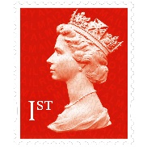

Fairtrade stall at Forest

2nd Sunday of the month



Prayer Pages

IN YOUR PRAYERS
If you know of someone who would appreciate being on our prayer list, please ensure you have the person's permission before passing their name to Michelle.
Please pray for Win De La Mare, Karen Harrison,
Rachel Meinke, Caroline Treharne, Joyce Baudains,
Margaret Boden-Heaume, Bob Cartmell,
Rev John Luff and his wife Carole,
Howard Ellis (Sandra’s son), Debbie Hobbs,
Colleen Ogier,
Sarah’s grandson Edward
And Philip Salmon

Bailiwick of Guernsey Churches Prayer Cycle for 2026
May 03 States of Guernsey / Parish constables, douzaine members, and their officers
May 09 LIBERATION DAY
May 10 Holy Trinity church / Guernsey Welfare
May 11-17 CHRISTIAN AID WEEK May 14 ASCENSION DAY
May 17 La Villiaze Evangelical Congregational church / Rohais Methodist church
May 24 PENTECOST (Prayer for the worldwide church)
May 31 Lay Ministers and Local Preachers

FACTOR 7
Please pray wherever you are: at home, work, in your car or shower, pray for
7 minutes at 7am and/or 7pm
FOCUS THIS MONTH

As we look forward to celebrating Liberation Day, pray that our traditional afternoon teas will be a time of fellowship, blessing and reflection for those who come along.

As we celebrate our liberation 81 years ago, give thanks to God for the freedom we enjoy today. Remember in prayer those who live in countries where there is war and suffering, that God would bring peace and healing.
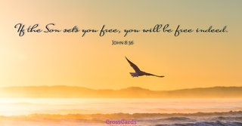

“Dear God” letters from children

Dear God, I went to this wedding, and they kissed right in church. Is that OK? Neil

Dear God, Thank you for the baby brother but what I prayed for was a puppy. Joyce

Dear God, Did you mean for the giraffe to look like that or was it an accident? Norma

Dear God, I bet it is very hard for you to love all of everybody in the whole world. There are only four people in our family, and I can never do it. Tom

